Automated Irrigation System using PID

(Detailed Outline)

Do Manh Thang - 20139091, Phan Quyet Thang - 20139050 and Nguyen Vu Tu - 20139094

Faculty of Electrical and Electronics Engineering,

Ho Chi Minh City University of Technology and Education

Ho Chi Minh City, Vietnam.

[Thangdo24092002@gmail.com](mailto:Thangdo24092002@gmail.com), [Quyetthangmarvel@gmail.com,](mailto:Quyetthangmarvel@gmail.com,) [nguyenvutu010702@gmail.com,](mailto:nguyenvutu010702@gmail.com,)

*Abstract*—This project, titled "Automated Irrigation System," aims to develop an automated system that waters crops based on soil moisture levels. The system is designed to optimize irrigation scheduling and reduce water usage while maximizing crop yields. The project uses a soil moisture sensor to measure the moisture content of the soil and activates a water pump when the moisture level is lower than the set threshold. The system is controlled by a microcontroller, which receives data from the sensor and activates the water pump accordingly. The project demonstrates the potential for low-cost, automated irrigation systems to improve water use efficiency and crop yields in small-scale agriculture.

# Introduction

* In this project, we created a system to help farmers conserve water while keeping their crops healthy.
* We built a device that detects when the soil is too dry, and waters the crops automatically.
* This system can save water and help farmers avoid overwatering, which can harm the environment and waste resources.

# System model

* Our system consists of a soil moisture sensor, a motor, a fan and an Arduino Uno microcontroller.
* The soil moisture sensor continuously measures the moisture level in the soil. When the moisture level exceeds a predefined setpoint, the sensor sends a signal to the Arduino Uno microcontroller. Upon receiving the signal, the microcontroller activates the fan. The fan is positioned near the soil surface and helps to evaporate excess moisture from the soil, thereby reducing the soil moisture level. The fan remains active until the moisture level reaches the desired setpoint. This closed-loop system allows for automatic regulation of soil moisture, preventing overwatering and promoting optimal growing conditions for the crops.

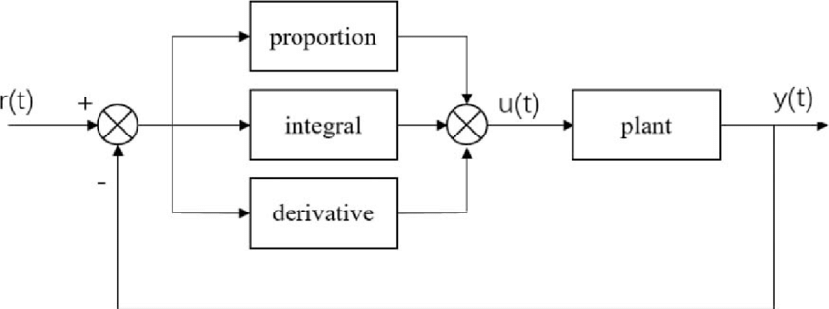

*Fig. 1: PID Structure*

# System model

* To build the system, we connected the soil moisture sensor and motor to the Arduino Uno using wires and breadboards.
* We programmed the Arduino Uno to read the sensor data and activate the motor when necessary.
* We tested the system using a small plant and adjusted the calibration until it worked effectively.

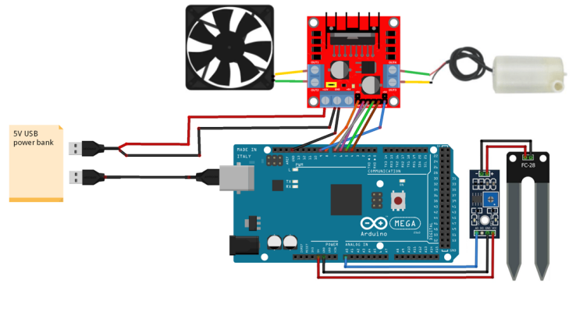

*Fig. 2: Connection Diagram*

# Implementation

In this section we will specify the sensors and the actuators that are used to counteract the measure provided by the specific sensors

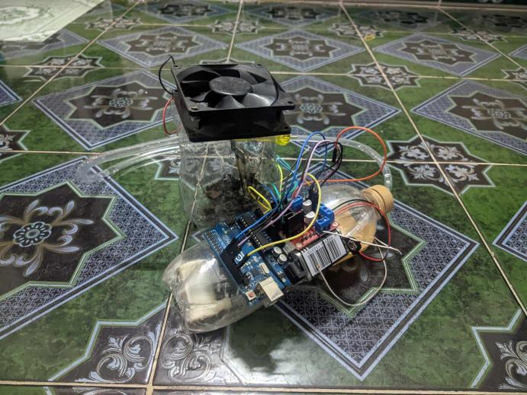

*Fig. 3: Automated Irrigation System Complete Setup*

# Limitation

# Conclusion